Wireless LAN Controller Lab

Purpose

The purpose of this lab was to set up a Wireless LAN Controller so we could connect remote hosts to an access point. Our goal was to set up four hosts, two in the 2.4 ghz spectrum and two in the 5 ghz spectrum. Unfortunately, 5 ghz was not supported in Packet Tracer, so instead we did all four in the 2.4 ghz spectrum. This lab taught me how to setup hosts and wirelessly connect them to an access point.

Background Information

In this lab, I used a Wireless LAN Controller to set up an access point and configure four wireless hosts. A Wireless LAN Controller, or WLC, is a device which manages wireless network access points that allow wireless devices to connect to the network. I used a WLC in this lab to setup one access point, which is a networking hardware device that allows other Wi-Fi devices to connect to a wired network. I used a lightweight access point for this lab, which means it cannot act independently, and must be managed by a WLC. I also implemented security to the networks through the access point using WPA2 Enterprise and WPA2-PSK. WPA2 Enterprise is a security protocol that uses a remote RADIUS server for authentication. It allows for more security than WPA2-PSK. WPA2-PSK is a less secure method of securing your network with a pre-shared key, or password. It is the type of security that would be used at home, while WPA2 Enterprise is the type of security that would be used in an enterprise. I used WPA2-PSK and WPA2 Enterprise in this lab across four different hosts which wirelessly connected to the access point.

Lab Summary

For this lab, I had to configure four hosts and wirelessly connect them to an access point. I needed to setup four in the 2.4 ghz spectrum, because 5 ghz was not supported by Packet Tracer. One host needed to have a pre-shared key for security, and the other needed to use AAA RADIUS for security. First, I had to setup the router, RADIUS server, and switch. I configured the router with DHCP, the server with AAA, and the switch with trunking and VLANs. I then connected a PC to the switch to act as an admin PC, an access point for the wireless hosts to connect to, and then the Wireless Lan Controller. Using the PC, I was able to access the WLC through the built-in web browser and configure the WLANs. In the WLC, I configured four WLANs, one for each VLAN, and setup the security on it. I then had to setup the interfaces for each VLAN which contained the IP address and network for each WLAN. I also then had to add the RADIUS server into the WLC, so the WLANs knew where it was located. After I configured the WLC settings, I then had to enter the PC wireless app in the hosts and connect to the SSIDs using the pre-shared key for two of them and using AAA authentication for the other two. Then, the hosts successfully connected to the access point and were given IP addresses through DHCP based on the SSID they were connected to.

Lab Commands

In this lab, I did not end up using any new commands. While I did have to configure a switch and a router, I did it using DHCP and switchport commands which I had previously learned. Most of the new content was configuring the WLC and its WLANs and setting up the wireless network for the hosts to connect to.

Problems

In this lab, I had a couple of problems while successfully getting the hosts to connect to the access point. The main problem I had happened after I successfully configured the network with a pre-shared key, I was unable to connect one of the hosts with Radius authentication. When it wasn’t working, I began to troubleshoot, and I found two problems. The first problem I found was that in the WLC configuration, I had accidentally set the Radius server IP to the wrong address, so I fixed it. Afterwards, I had another problem in that I had not enabled AAA authentication within the server. I had not known I had to until I went through its settings, and once I enabled AAA and set up the username and password, I was able to connect the hosts successfully. The final problem I had was configuring a 5ghz network. I looked through the settings and I could not find anything, so I looked up how to do it online on a real WLC. Once I had figured that out, I went into the settings and found out that packet tracer does not support 5ghz networks, so I had to settle for 2.4ghz. After all this, I was successfully able to connect the hosts to the access point using AAA authentication and a pre-shared key.

Conclusion

Throughout this lab, I was able to configure a Wireless LAN Controller, set up multiple SSIDs with different types of security such as a pre-shared key and AAA, and successfully connected multiple hosts to the SSIDs. I had a few mistakes along the way while setting up AAA authentication, but I was able to fix it in the end. Overall, this lab helped me learn how to use WLCs and how to set up wireless hosts to connect to it.

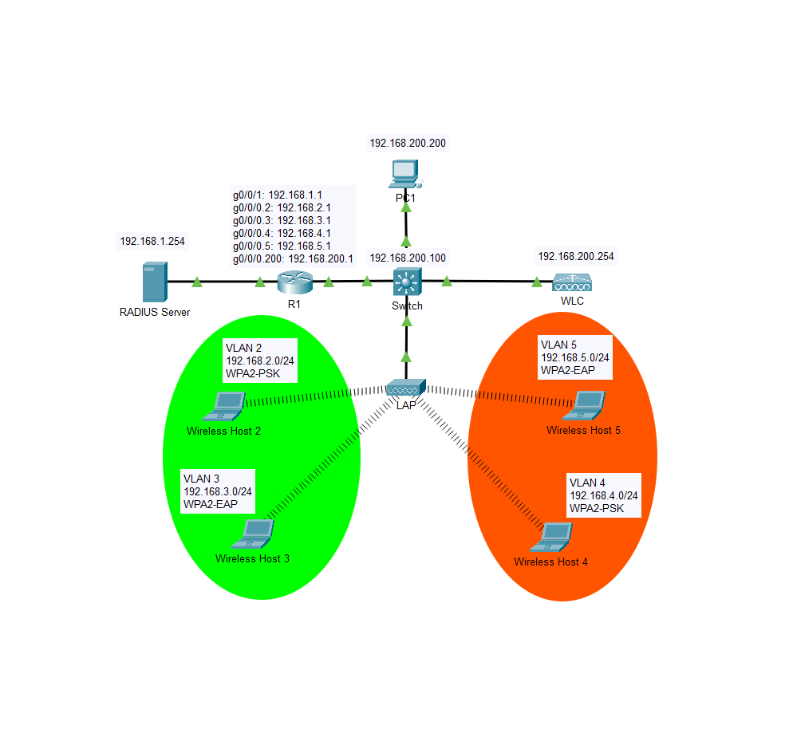Lab Diagram

Configurations

-------------

R1

-------------

version 15.4

no service timestamps log datetime msec

no service timestamps debug datetime msec

no service password-encryption

hostname Router

ip dhcp excluded-address 192.168.5.1

ip dhcp excluded-address 192.168.2.1

ip dhcp excluded-address 192.168.3.1

ip dhcp excluded-address 192.168.4.1

ip dhcp pool wireless_clients

network 192.168.5.0 255.255.255.0

default-router 192.168.5.1

ip dhcp pool wireless1

network 192.168.2.0 255.255.255.0

default-router 192.168.2.1

ip dhcp pool wireless2

network 192.168.3.0 255.255.255.0

default-router 192.168.3.1

ip dhcp pool wireless3

network 192.168.4.0 255.255.255.0

default-router 192.168.4.1

ip cef

no ipv6 cef

spanning-tree mode pvst

interface GigabitEthernet0/0/0

no ip address

duplex auto

speed auto

interface GigabitEthernet0/0/0.2

encapsulation dot1Q 2

ip address 192.168.2.1 255.255.255.0

interface GigabitEthernet0/0/0.3

encapsulation dot1Q 3

ip address 192.168.3.1 255.255.255.0

interface GigabitEthernet0/0/0.4

encapsulation dot1Q 4

ip address 192.168.4.1 255.255.255.0

interface GigabitEthernet0/0/0.5

encapsulation dot1Q 5

ip address 192.168.5.1 255.255.255.0

interface GigabitEthernet0/0/0.200

encapsulation dot1Q 1 native

ip address 192.168.200.1 255.255.255.0

interface GigabitEthernet0/0/1

ip address 192.168.1.1 255.255.255.0

duplex auto

speed auto

interface GigabitEthernet0/0/2

no ip address

duplex auto

speed auto

shutdown

interface Vlan1

no ip address

shutdown

ip classless

ip flow-export version 9

line con 0

line aux 0

line vty 0 4

login

end

-------------

S1

-------------

version 16.3.2

no service timestamps log datetime msec

no service timestamps debug datetime msec

no service password-encryption

hostname Switch

no ip cef

no ipv6 cef

spanning-tree mode pvst

interface GigabitEthernet1/0/1

switchport access vlan 200

switchport mode access

switchport nonegotiate

interface GigabitEthernet1/0/2

interface GigabitEthernet1/0/3

interface GigabitEthernet1/0/4

interface GigabitEthernet1/0/5

interface GigabitEthernet1/0/6

interface GigabitEthernet1/0/7

interface GigabitEthernet1/0/8

interface GigabitEthernet1/0/9

interface GigabitEthernet1/0/10

interface GigabitEthernet1/0/11

interface GigabitEthernet1/0/12

interface GigabitEthernet1/0/13

interface GigabitEthernet1/0/14

interface GigabitEthernet1/0/15

interface GigabitEthernet1/0/16

interface GigabitEthernet1/0/17

interface GigabitEthernet1/0/18

interface GigabitEthernet1/0/19

interface GigabitEthernet1/0/20

interface GigabitEthernet1/0/21

interface GigabitEthernet1/0/22

switchport trunk native vlan 200

switchport trunk encapsulation dot1q

switchport mode trunk

switchport nonegotiate

interface GigabitEthernet1/0/23

switchport trunk native vlan 200

switchport trunk encapsulation dot1q

switchport mode trunk

switchport nonegotiate

interface GigabitEthernet1/0/24

switchport trunk native vlan 200

switchport trunk encapsulation dot1q

switchport mode trunk

switchport nonegotiate

interface GigabitEthernet1/1/1

interface GigabitEthernet1/1/2

interface GigabitEthernet1/1/3

interface GigabitEthernet1/1/4

interface Vlan1

ip address 192.168.200.100 255.255.255.0

ip default-gateway 192.168.200.1

ip classless

ip flow-export version 9

line con 0

line aux 0

line vty 0 4

login

end

-----------------------------------

Pings R1 to WLC and Hosts

-----------------------------------

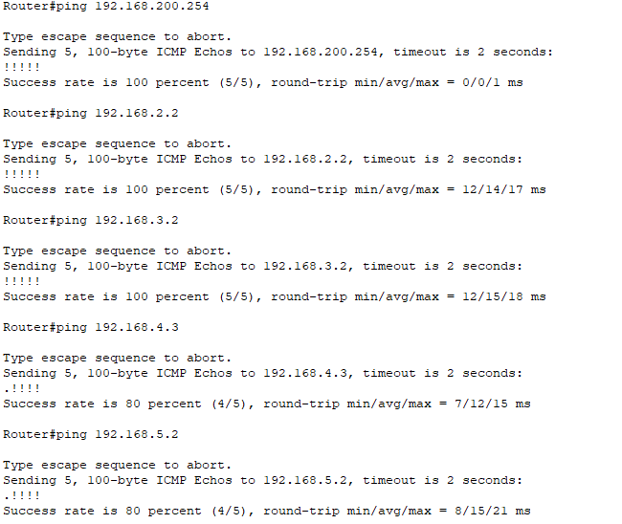

--------------------------------------------------

Ping Hosts to Default Gateway and WLC

--------------------------------------------------

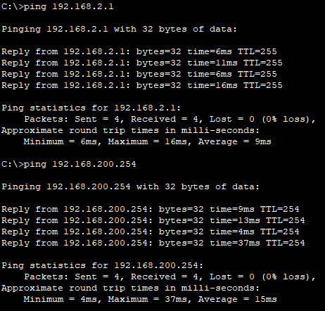 Wireless Host 2 Wireless Host 3

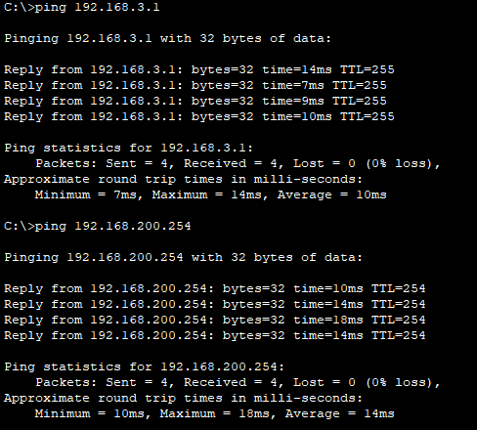

Wireless Host 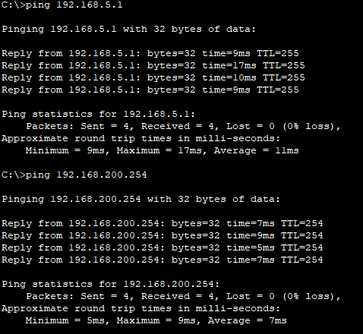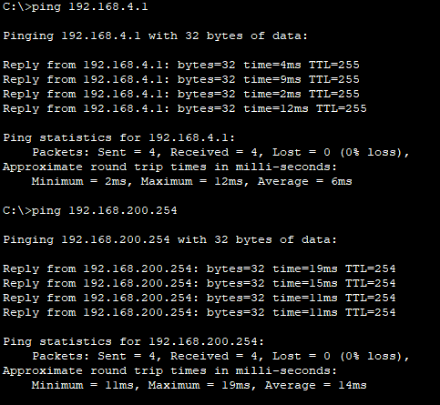4 Wireless Host 5

----------------

R1 IP Route

----------------

